

**OFFLINE JUDGE**

**By**

**Md. Raihan Nishat**

**ID: 182-35-2518**

**Batch: 26th**

**Department of Software Engineering**

**Faculty of Science & Information Technology**

**Daffodil International University**

**A course project (SWE 231 : Software Engineering Project submitted in fulfillment of the requirement for the degree of Bachelor of Science in Software Engineering .**

**DECLARATION**

**==========**

**It hereby declared that this course project title on “Departmental Store Management**

**System” under the supervision of Dr. Md. Asraf Ali, Associate Professor, Department**

**of Software Engineering, Daffodil International University. It is also declared that**

**neither this project nor any part of this has been submitted elsewhere for award or any**

**Certified By:**

**============**

**Dr. Md. Asraf Ali**

**Associate Professor**

**Department of Software Engineering**

**Faculty of Science & Information Technology**

**Daffodil International University**

**ACKNOWLEDGEMENT**

**================**

**First of all, I am grateful to The Almighty God for giving me the ability to complete this**

**project. proud Today I am felling for myself. Because, to be a student of Daffodil**

**International University. And I am thankful to Daffodil International University for giving**

**me a chance to give me a chance to prove myself by showing this project. I thank to our**

**Department Head Dr. Touhid Bhuiyan. And I want to thank to our respected class teacher**

**Dr. Md. Asraf Ali for supporting and given your guideline and valuable advices.**

**Competitive programming is a mind sport usually held over the Internet or a local network, involving participants trying to program according to provided specifications. Contestants are referred to as sport programmers. Competitive programming is recognized and supported by several multinational software and Internet companies, such as Google[1][2] and Facebook.[3] There are several organizations who host programming competitions on a regular basis.**

**ABSTRACT**

**=======**

**This is project documentation about “OFFLINE JUDGE”.While doing this prject I explored new thing .**

**I have also improved my programming skill by doing this project.**

**This project will help a contester to bulid problem solving skill.**

**The user have to log in with username and password. Without log in user can’t enter. User can manage the whole system.**

**PROJECT OBJECTIVE**

**=============**

**This project will help a contester to bulid problem solving skill.**

**METHODOLOGY**

**===========**

**At first needed to be log in with defined password. User is only manager. After**

**successfully logged in manager can do all the things of this system.**

**Log in**

**====**

**User will give id and password for log in.**

**Main Menu**

**========**

**After successfully entered password manager can use all the option from main menu.**

**1. HOME**

**2. LOG OUT**

**3. PROBLEM SET**

**4. SUBMIT**

**5. HINTS**

**6. ABOUT**

**7. EXIT**

**In this option we can use access offline judge.**

**HOME**

**====**

**When we choose no. 1 then it will show us log in page.**

**LOG OUT**

**=======**

**When we choose no. 2 then it will show us log out page.**

**PROBLEM SET**

**=========**

**When we choose no. 3 then it will show us many problem set.**

**SUBMIT**

**=====**

**When we choose no. 4 then it will show problem ID and**

**You enter problem ID after submit code .**

**HINTS**

**====**

**When we choose no. 5 then it will show all problem hints.**

**ABOUT**

**=====**

**When we choose no. 6 then it will show about this software.**

**EXIT**

**===**

**When we choose no. 7 then software exit.**

**USE CASE**

**HOME**

**OLG OUT**

**PROBLEM**

**SUBMIT**

**HINTS**

**ABOUT**

**EXIT**

**Functional Requirement :**

==========================================

**1. HOME**

**2. LOG OUT**

**3. PROBLEM SET**

**4. SUBMIT**

**5. HINTS**

**6. ABOUT**

**7. EXIT**

**User can registration or log in with previous id and password.Or can create new id and password.**

**HOME**

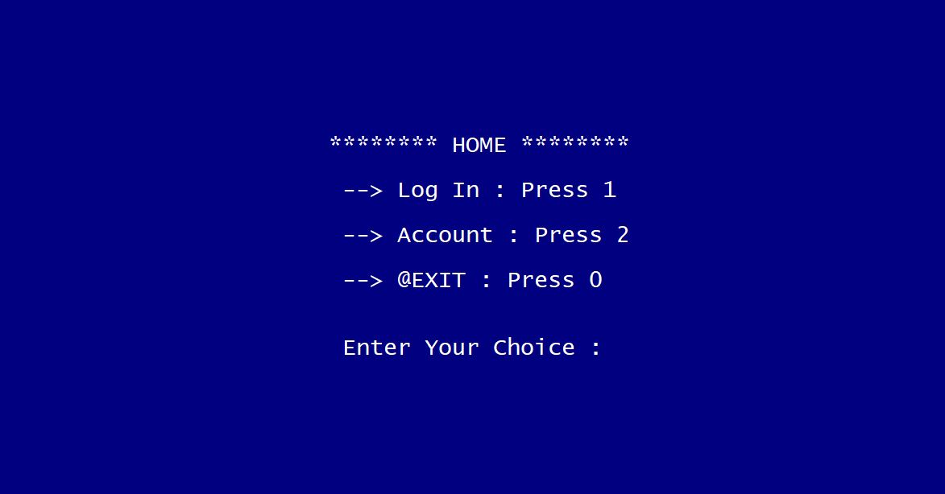

**MENU**

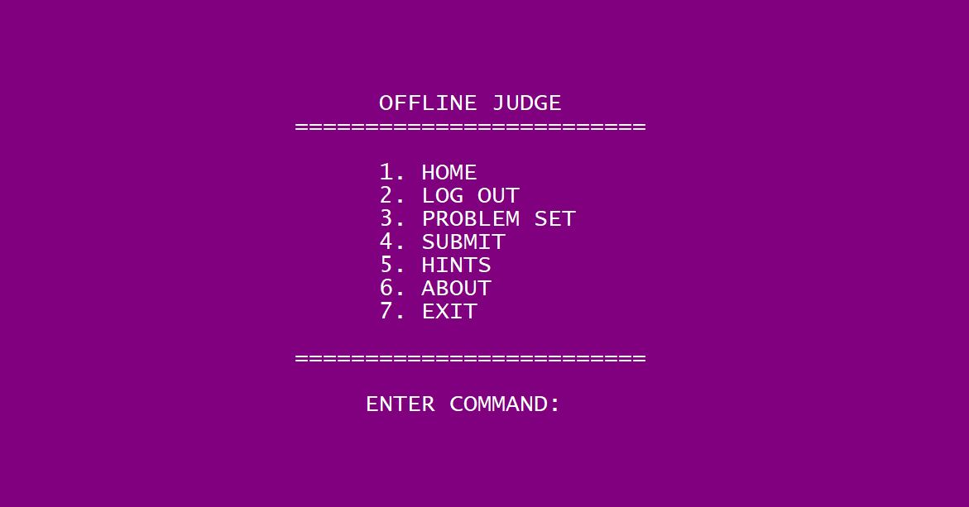

**PROBLEM SET**

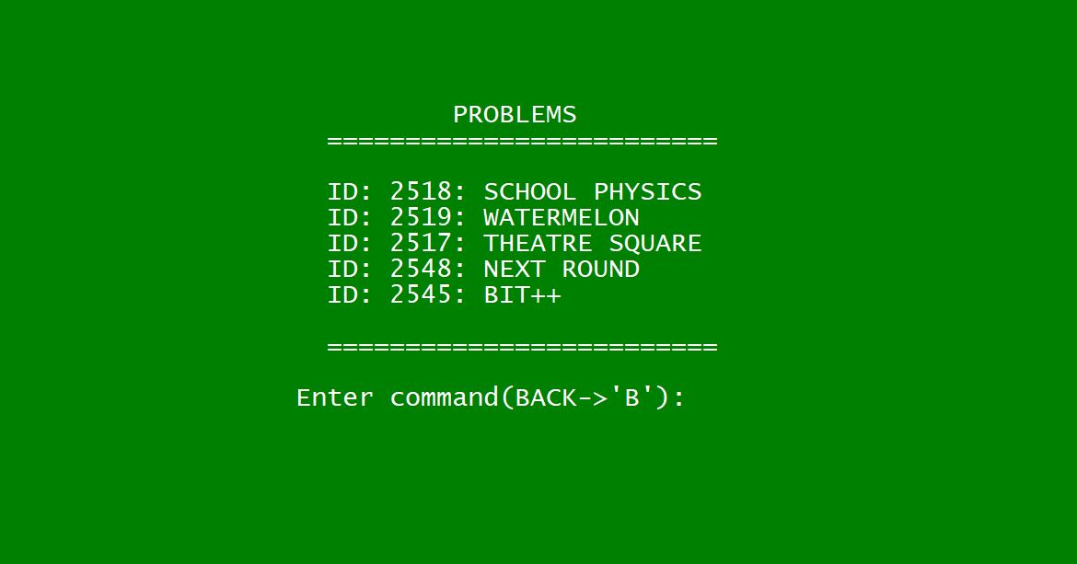

**SUMBIT**

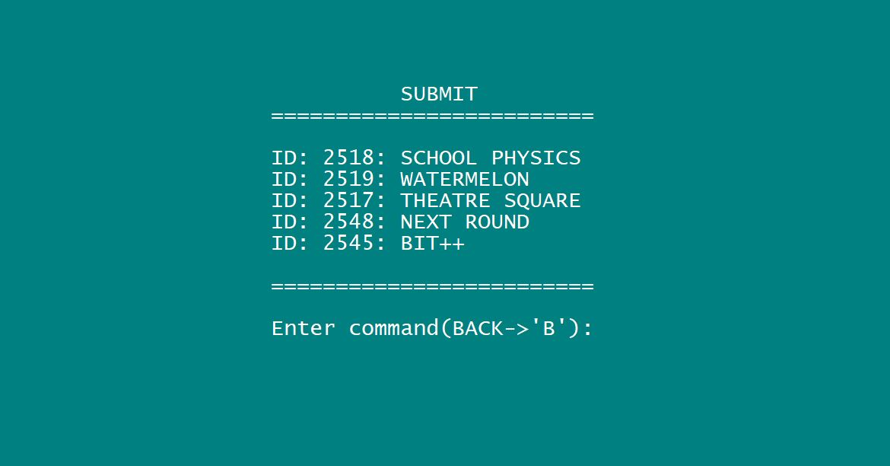

**ACCEPTED**

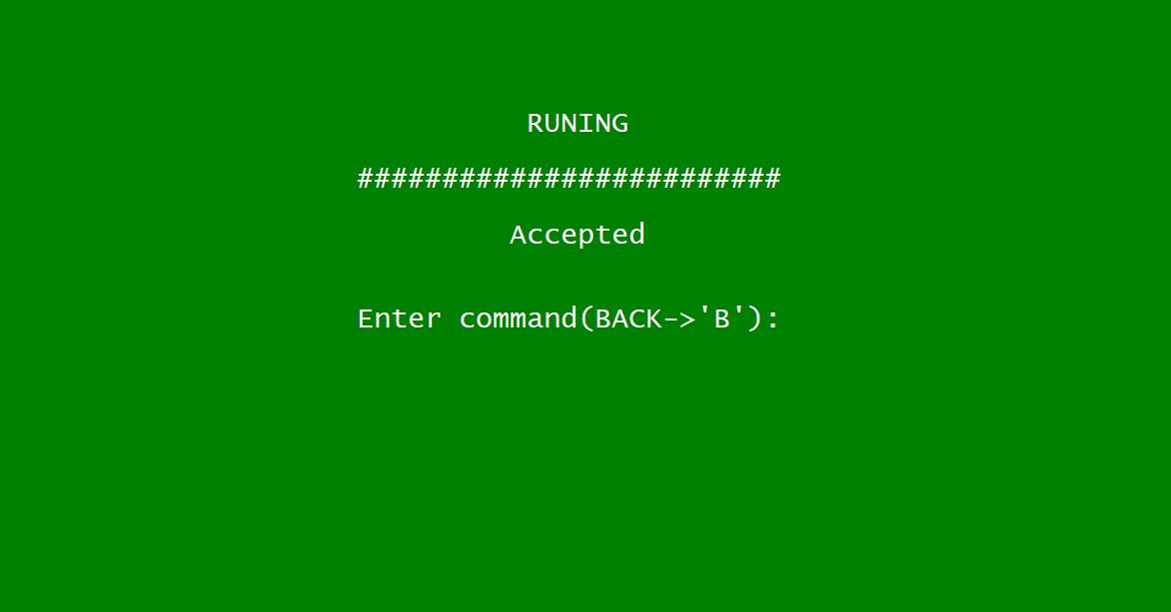

**WRONG ANSWER**

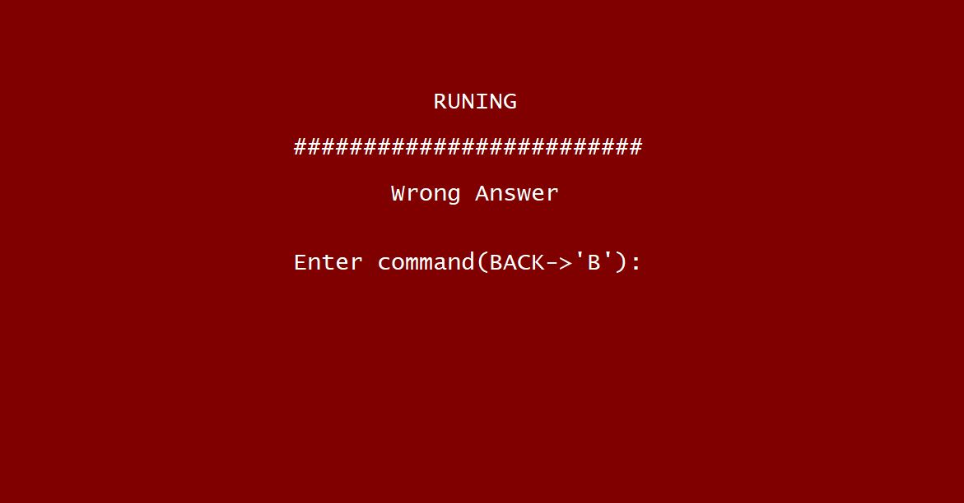

**GOOD BYE**